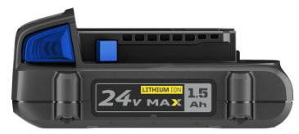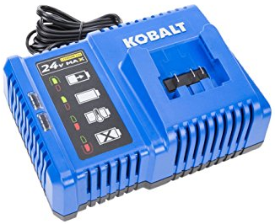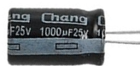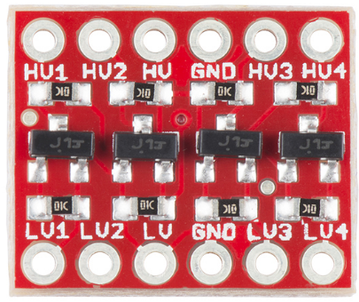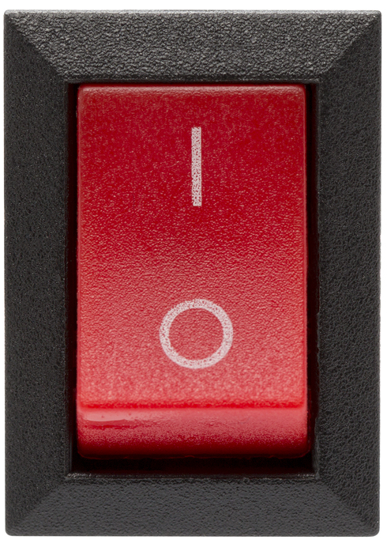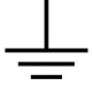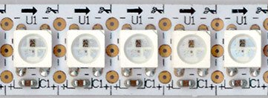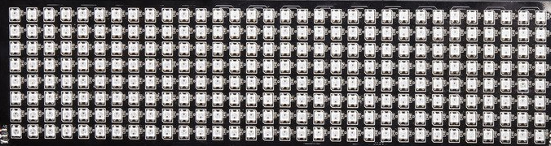

P19

P20

S1

S2

S3

S4

S5

S6

S1

S2

S3

S4

S8

S5

**3.3V**

**5V**

**24V**



S7



S6

S7

S8

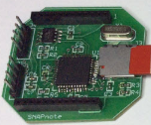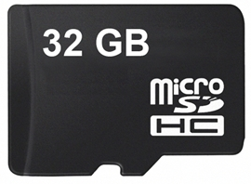

**3.3V**

P21

P22

P20

P21

P22

P19

P18

P18

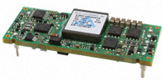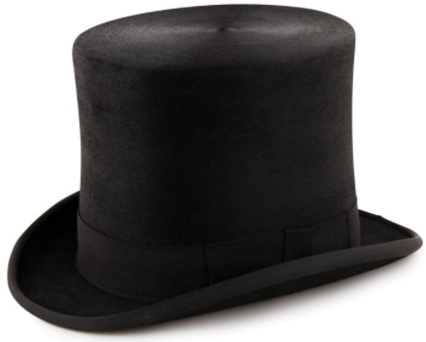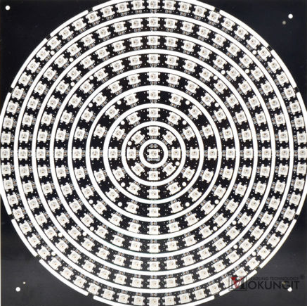

**5V**

S1

S3

S2

S4

S5

S6

S7

S8

241 pixels in the center of the top.

Four grids around the body. Each grid is 32*8 = 256 pixels.

200 pixels in short strips filling out the long axis of the top.

64 strips of 8 wrap around the brim. Divided into 2 sets of 256 pixels.

200 + 241 + 256*4 + 256*2 = 1977 total pixels